4 **. Create an application that obtains result from an activity?**

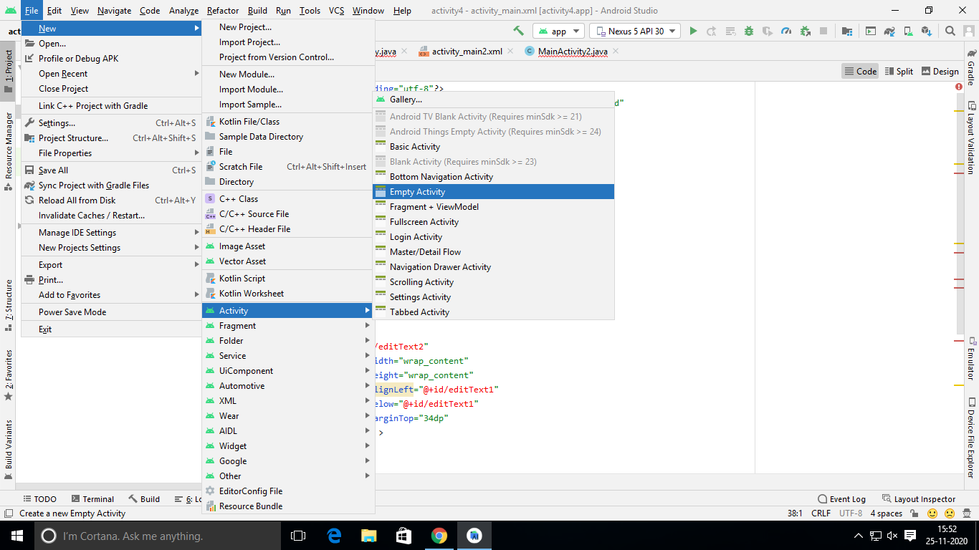

**Activity1_main.xml:::**

*<?*xml version="1.0" encoding="utf-8"*?>*<RelativeLayout xmlns:android="http://schemas.android.com/apk/res/android"  
 xmlns:app="http://schemas.android.com/apk/res-auto"  
 xmlns:tools="http://schemas.android.com/tools"  
 android:layout_width="match_parent"  
 android:layout_height="match_parent"  
 tools:context=".MainActivity">  
  
 <EditText  
 android:id="@+id/editText1"  
 android:layout_width="wrap_content"  
 android:layout_height="wrap_content"  
 android:layout_alignParentTop="true"  
 android:layout_centerHorizontal="true"  
 android:layout_marginTop="24dp"  
 android:ems="10" />  
  
 <EditText  
 android:id="@+id/editText2"  
 android:layout_width="wrap_content"  
 android:layout_height="wrap_content"  
 android:layout_alignLeft="@+id/editText1"  
 android:layout_below="@+id/editText1"  
 android:layout_marginTop="34dp"  
 android:ems="10" >  
 <requestFocus />  
 </EditText>  
 <Button  
 android:id="@+id/button1"  
 android:layout_width="wrap_content"  
 android:layout_height="wrap_content"  
 android:layout_centerHorizontal="true"  
 android:layout_centerVertical="true"  
 android:text="sum" />  
  
</RelativeLayout>

**Main-activity1.java**:

package com.example.activity4;  
import android.content.Intent;  
import android.support.v4.app.INotificationSideChannel;  
import android.os.Bundle;  
import android.view.View;  
import android.widget.Button;  
import android.widget.EditText;  
import android.widget.Toast;  
  
import androidx.appcompat.app.AppCompatActivity;  
  
public class MainActivity extends AppCompatActivity {  
 private EditText et1,et2;  
 private Button buttonSum;  
 @Override  
 protected void onCreate(Bundle savedInstanceState) {  
 super.onCreate(savedInstanceState);  
 setContentView(R.layout.*activity_main*);  
 addListenerOnButton();  
 }  
 public void addListenerOnButton() {  
 et1 = (EditText) findViewById(R.id.editText1);  
 et2 = (EditText) findViewById(R.id.editText2);  
 buttonSum = (Button) findViewById(R.id.button1);  
  
 buttonSum.setOnClickListener(new View.OnClickListener() {  
  
  
 public void onClick(View view) {  
 String value1 = et1.getText().toString();  
 String value2 = et2.getText().toString();  
 int a = Integer.*parseInt*(value1);  
 int b = Integer.*parseInt*(value2);  
 int sum = a + b;  
 Intent i=new Intent(getApplicationContext(),Main2Activity.class);  
 i.putExtra("mamboo",sum);  
 startActivity(i);  
  
  
 *//Toast.makeText(getApplicationContext(), String.valueOf(sum), Toast.LENGTH_LONG).show();* }  
 });  
 }  
}

**activity2 main.xml:**

*<?*xml version="1.0" encoding="utf-8"*?>*<RelativeLayout xmlns:android="http://schemas.android.com/apk/res/android"  
 xmlns:app="http://schemas.android.com/apk/res-auto"  
 xmlns:tools="http://schemas.android.com/tools"  
 android:layout_width="match_parent"  
 android:layout_height="match_parent"  
 tools:context=".Main2Activity">  
  
 <TextView  
 android:id="@+id/textView"  
 android:layout_width="wrap_content"  
 android:layout_height="wrap_content"  
 android:text="TextView" />  
  
</RelativeLayout>

**Main-activity2.java:**

package com.example.activity4;  
main2activity.java::::  
import android.content.Intent;  
import android.support.v4.app.INotificationSideChannel;  
import android.os.Bundle;  
import android.widget.Button;  
import android.widget.TextView;  
  
import androidx.appcompat.app.AppCompatActivity;  
  
public class Main2Activity extends AppCompatActivity  
{  
 TextView t;  
  
  
 @Override  
 protected void onCreate(Bundle savedInstanceState) {  
 super.onCreate(savedInstanceState);  
 setContentView(R.layout.*activity_main2*);  
 t=(TextView) findViewById(R.id.*textView*);  
 Intent i=getIntent();  
 int t1=i.getIntExtra("mamboo",0);  
 t.setText(String.*valueOf*(t1));  
  
 }  
}

**output:**

